**CS5560 Knowledge Discovery Management**

**LAB ASSIGNMENT #2**

**Lab Submission through the following link before June 20, 2017 (T) 11:59PM.**

<https://goo.gl/forms/eGLZpAZwQYimFlI03>

**Submission:**

***Lab Submission has two parts In Class Question and Take home Question. In Class Questions must be completed in class (on June 14th) and shown to the TA’s. On the above given deadline (June 20th), you must submit your work on all the questions. The submission includes the following three parts,***

1. ***Report your lab work through Wiki Page-Github (See Tutorial 1A)***
2. ***Submit source code and other materials (data, etc) to Github. Include the Github link through google forms***
3. ***A source Code file (a single text file combined all source code files) through turnitin Link (Blackboard) (Suggested similarity score <=35%)***

**Lab 2 Assignment:**

1. ***In Class Question***

**Generate the output (changes or transformations in the data) manually when the following Spark tasks are applied on the input text. Show your output in details.**

***Input***:

The dog saw John in the park

The little bear saw the fine fat trout in the rocky brook.

**Spark Tasks:**

* 1. Map vs FlatMap
  2. Map Reduce
  3. Group by Starting Letter (Draw diagram how the spark methods used changes the data similar wordcount diagram as shown below)

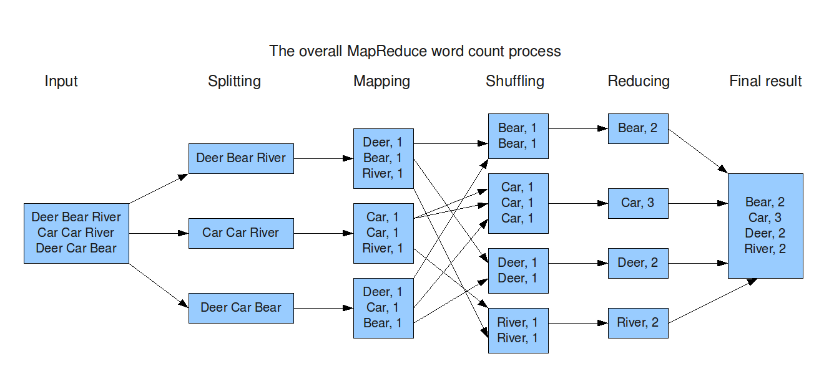

1. ***In Class Question***

**Write a simple spark program to read a dataset and group each word by the starting letter of its lemmatized word (in this exercise, we assume case-not-sensitive).**

* 1. Write a function ***F*** in Java using CoreNLP to extract Lemmatized Words
  2. Call the function ***F*** from a ***Spark*** ***Transformation*** function
  3. Use 1 (c) diagram to guide the rest of the task.

An example of this task is shown below:

***Input:*** This is a question answering system. The question is from Quora.

***Output:***

T=> This, The

A => a, answer

I => is

Q => question, Quora

S => system

F => from

Note that the *lemmatized* word of***answering*** *is* **answer.**

1. ***Take home Question***

**Create a simple question answering system as an extension of the dataset and tasks done in (2). Continuation from Tutorial 1B. Make sure to use at least two *Spark Transformations and two Spark Actions.***

* 1. Use the Question Type

(https://en.wikipedia.org/wiki/Interrogative_word). Suggestions are When, Who, What. Also try your questions with Google Search engine (<https://google.com>) or the Yahoo AnswerDemo (https://answers.yahoo.com/)

* 1. The three steps are the below diagram is going to be basic idea of your Q&A System

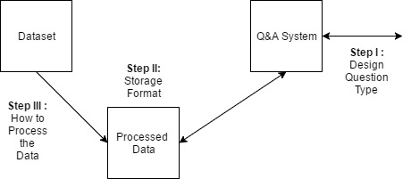

* 1. Start with Step I for the System, it will be easier to process data based on the question.

**[note that the first three (a), (b), (c) questions are same as the Tutorial 1(B)]**

* 1. Spark Implementation for Step III in the above diagram (How to process the Data)
     1. ***For Step III, Part 1 Reading Dataset:*** Use spark methods to read the dataset. (Hint: Check Tutorial 2B ppt)
     2. ***For Step III, Part 2 Processing Dataset:*** Use the spark’s transformation and actions to call the coreNLP function.

Draw a process diagram for spark methods used (similar to the word count diagram) to guide you through the coding process. Include your diagram in your report.